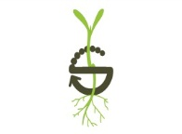
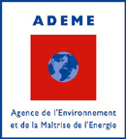

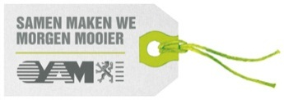
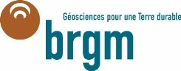



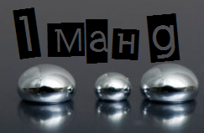

Online conference in combination with National hotspots
Organised with the financial support of:
Final Workshop IMaHg:
Enhanced knowledge in mercury fate and transport for Improved Management of Hg soil contamination
29th November 2013
The workshop is free of charge
There are limited numbers of places in each hotspot.
Information for reaching the meeting point will be sent to you with the confirmation of your registration.
Name:
Surname:
Organization / Company:
Address:

Hot spot location:
Paris – Gare de Lyon (France) □
London – Central London (England) □
Stockholm (Sweden) □
Mechelen (Belgium) □
Gouda (The Netherlands) □
For registration,
Please fill in the following registration form and send it back to imahg@brgm.fr

